The First Non Repeated Character In A String

DESCRIPTION:
You need to write a function, that returns the first non-repeated character in the given string.
If all the characters are unique, return the first character of the string.
If there is no unique character, return null in JS or Java, None in Python, '\0' in C.
You can assume, that the input string has always non-zero length.

SOLUTION:
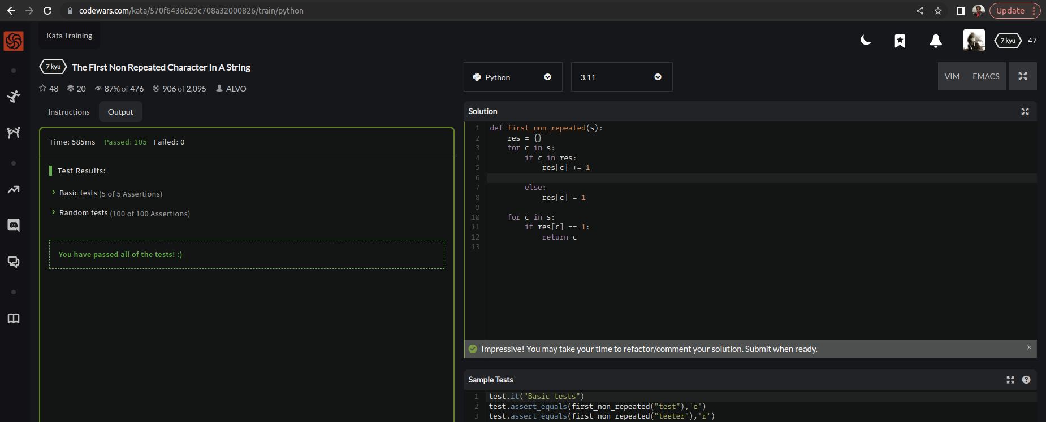

EXPLANATION:
The function works by first creating a dictionary to keep track of the count of each character in the input string. It then iterates over the string again and returns the first character it finds with a count of 1. If no non-repeated character is found, the function returns None. Although to reduce LOC return None is not mention but it will prove the given test cases true.

